Assignment 5: Conditional

Statement (Advanced)

Name: Harshal Atre Balkrishna

Roll NO. : A-76

1.A function f is defined as follows;

F(x) = ax 3-Bx 2 + cx – d if x > k

= 0 if x = k

= - ax 3 + bx 2-Cx + d if x < k

Write a program to accept a, b, c, d, k and x. and display the value of f(x).

Answer:

Source code:

#include <stdio.h>

#include <math.h>

Int main(){

Int fx,a,b,c,d,k,x;]

Printf(“The function works as\n fx= ax^3-bx^2+cx-d , if x>k\n fx=0 , if x=k\n fx= -ax^3+bx^2- cx+d,if x<k\n”);

Printf(“Enter The Value of a \n”);

Scanf(“%d”,&a);

Printf(“Enter The Value of b \n”);

Scanf(“%d”,&b);

Printf(“Enter The Value of c \n”);

Scanf(“%d”,&c);

Printf(“Enter The Value of d \n”);

Scanf(“%d”,&d);

Printf(“Enter The Value of k \n”);

Scanf(“%d”,&k);

Printf(“Enter The Value of x \n”);

Scanf(“%d”,&x);

If(x>k)

{

Fx=(a\*x\*x\*x)-(b\*x\*x)+(c\*x)-d;

Printf(“The value of x is greater than k/n”);

}

Else if(x=k)

{

Fx=0;

Printf(“The value of x is equal to k \n”);

}

Else if(x<k)

{

Fx=-(a\*x\*x\*x)+(b\*x\*x)-(c\*x)+d;

Printf(“The value of x is smaller than \n”);

}

Printf(“The output of function is %d”,fx);

}

Output:

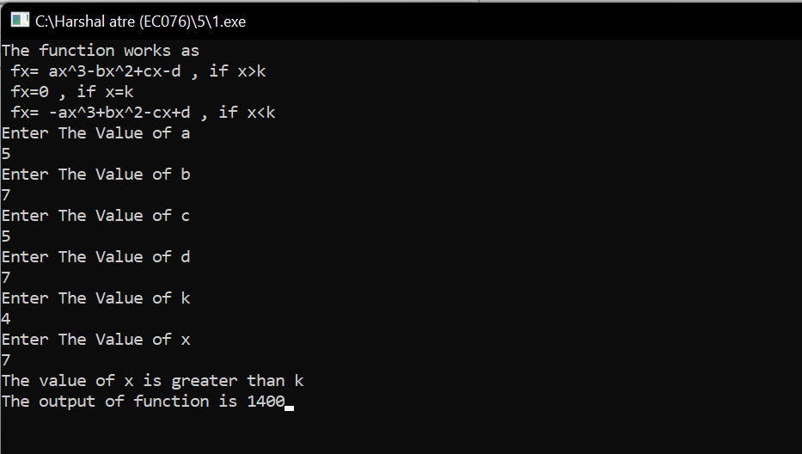

2.

Write a program to read marks from the keyboard and display equivalent grade.

(Use if-else if ladder)

Marks Grade

100 – 80. Distinction

60 – 79 First Class

35 – 59 Second Class

0 – 35. Fail

Source code:

#include <stdio.h>

#include<conio.h>

int main(){

int marks;

printf("Enter Your marks\n");

scanf("%d",&marks);

if(100>= marks >=80){

printf("Distinction\n");

}

else if(79>= marks <=60){

printf("First class\n");

}

else if(59>= marks <=35){

printf("Second class");

}

else if(35>= marks <=0){

printf("Fail");

}

getch();

}

Output:

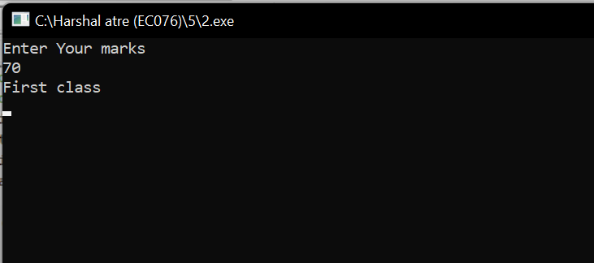

3. Write programs for the following:

1.Take two numbers of float and divide the first number by second and show the result as integer number.

2.Take the first number as -VE integer and second as +VE float, divide the first by second and display output as integer number.

3.Take the first number as +VE float and second number as -VE integer, divide the first number by second and display output in the float.

Answer:

Source code:

3.1

#include <stdio.h>

#include<conio.h>

int main(){

float a,b;

printf("Enter the Numerator ");

scanf("%f",&a);

printf("Enter the Denominator ");

scanf("%f",&b);

int ans=a/b;

printf( "The Answer is %d ",ans);

getch();

}

3.2

#include <stdio.h>

#include<conio.h>

int main(){

int a;

float b;

printf("Enter the Numerator ");

scanf("%d",&a);

printf("Enter the Denominator ");

scanf("%f",&b);

int ans =a/b;

printf("%d",ans);

getch();

}

3.3

#include <stdio.h>

#include<conio.h>

int main(){

float a;

int b;

printf("Enter the Numerator ");

scanf("%f",&a);

printf("Enter the Denominator ");

scanf("%d",&b);

float ans=a/b;

printf("%f",ans);

getch();

}

Output:

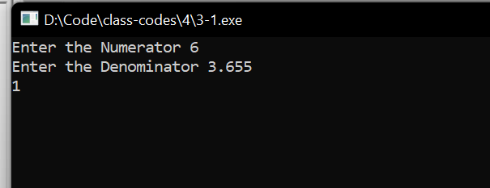

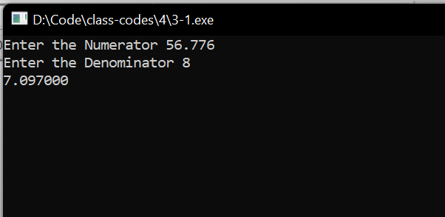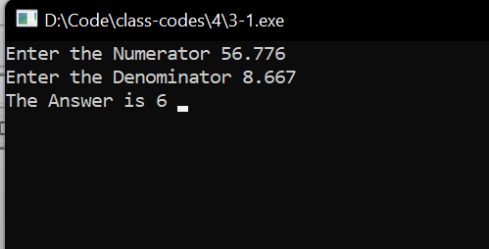

5.

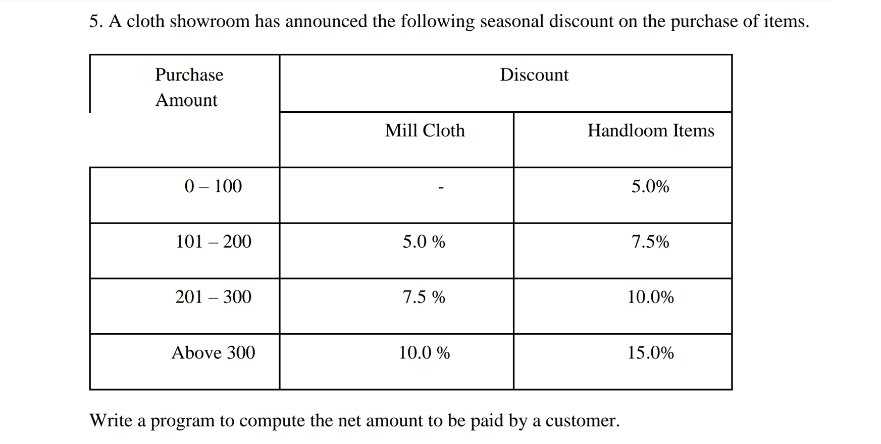

Answer:

Source code:

#include <stdio.h>

#include<conio.h>

int main(){

float parchaseAmt;

printf("Enter the purchase amount ");

scanf("%f",&parchaseAmt);

float bill,milld,handd;

if(0<=parchaseAmt && parchaseAmt<=100){

milld=0;

handd=(5\*parchaseAmt)/100;

printf("Mill cloth discount %.02f\n",milld);

printf("Handloom Items discount %.02f\n",handd);

}

else if(101<=parchaseAmt&& parchaseAmt<=200){

milld=((5)\*parchaseAmt)/100;

handd=((7.5)\*parchaseAmt)/100;

printf("Mill cloth discount %.02f\n",milld);

printf("Handloom Items discount %.02f\n",handd);

}

else if(201<=parchaseAmt&& parchaseAmt<=300){

milld=((7.5)\*parchaseAmt)/100;

handd=((10)\*parchaseAmt)/100;

printf("Mill cloth discount %.02f\n",milld);

printf("Handloom Items discount %.02f\n",handd);

}

else if(parchaseAmt>=300){

milld=((10)\*parchaseAmt)/100;

handd=((15)\*parchaseAmt)/100;

printf("Mill cloth discount %.02f\n",milld);

printf("Handloom Items discount %.02f\n",handd);

}

else{

printf("invalid input");

}

bill=parchaseAmt-(milld+handd);

printf("The Net Amount To Pay is %.02f\n",bill );

getch();

}

Output:

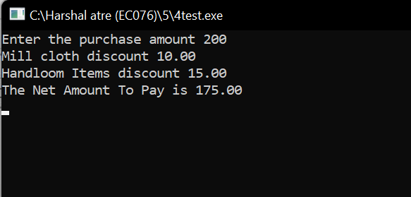

6.

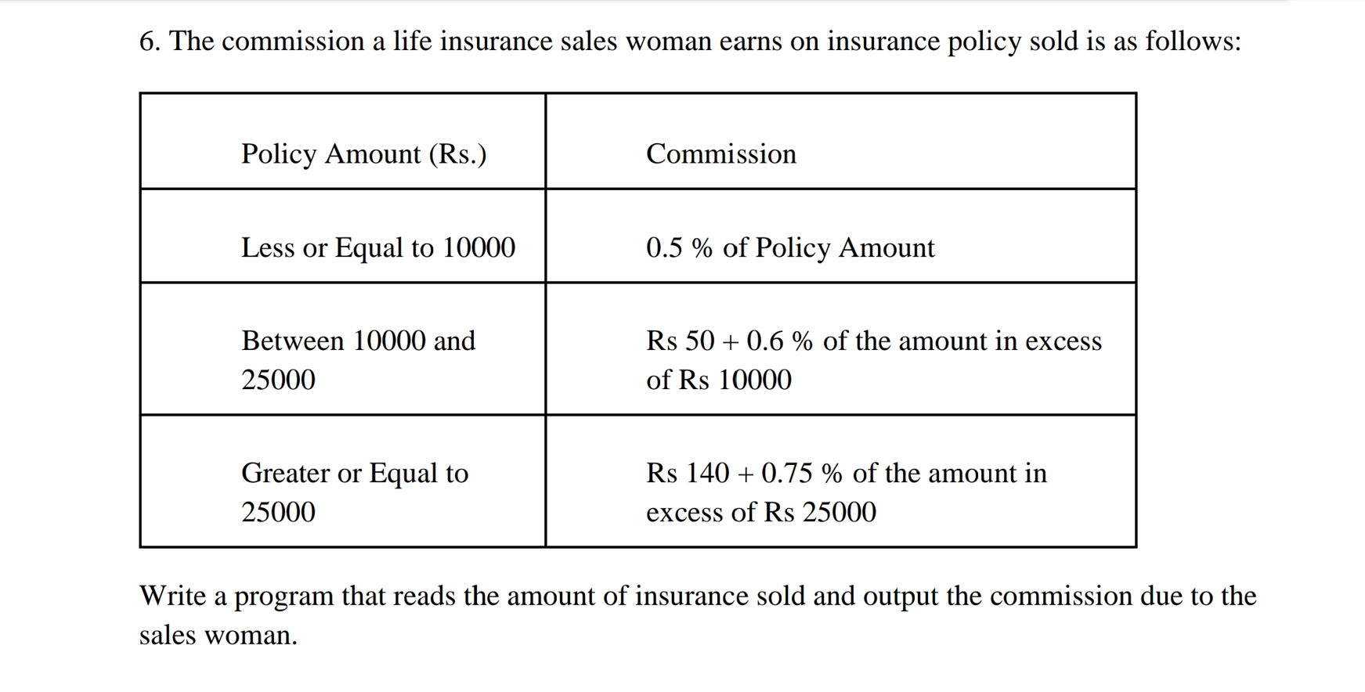

Answer:

Source code:

#include <stdio.h>

#include<conio.h>

int main(){

int noOFpolicy,amtOFpolicy;

float commission;

printf("Enter the no. of policy and the amount of policy ");

scanf("%d%d",&noOFpolicy,&amtOFpolicy);

if(amtOFpolicy<=10000){

commission=amtOFpolicy\*noOFpolicy\*0.005;

}

else if(amtOFpolicy<=25000 && amtOFpolicy>=10000){

commission=50 + (amtOFpolicy-10000)\*noOFpolicy\*0.006;

}

else if(amtOFpolicy>25000){

commission=140 + (amtOFpolicy-25000)\*noOFpolicy\*0.0075;

}

else{

printf("Invalid input");

commission=0;

}

printf("Total commision due to sales woman is %.02f",commission);

getch();

}

Output:

